Python Tool Box

Variable:
Give a name for constant number or other stuff

Variable type:
- String: something with quotation mark. Single quotation mark is as same as double’s
- Integer: number like 123, 4…
- Float: number with dot.
3 // just save the integer part of the answer.
4 print: print the data on the terminal
for string: “jack” + “is a boy” => “Jack is a boy”. Note: you cannot use ‘-’, ‘/’, “*”, “//” in string operation.
5 input(“XXX”) allow you to input something into the python code.
6 int(XXX) convert XXX into integer type.
7.type(var) present the var type

3.True and False

Amy is a girl => True
Jack is a boy’s name => True
Lisa is a boy’s name => false;
Sun is a cold planet => false

% (mod) 9 % 3 => 0 9 % 7 = 2

Identify even number and odd:
Even: 0,2, 4,8,10,... even % 2 == 0
Odd: 9, 7,5,1 odd % 2 == 1

If statement format:

If XXXX (is true):
(4 white space) do something.....
Elif XXXXX (is true)
(4 white space) do something.....
Else:
(4 white space) do something.....

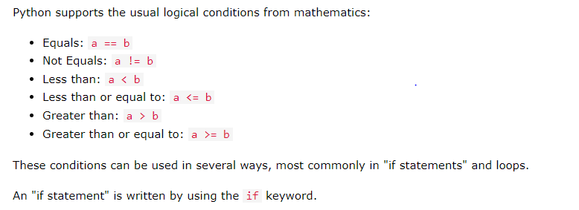

Homework :

Input a number and identify , it is a odd number or an even number. If is an odd number print “it is a odd number” else print “it is a even number

”
If enter 10 print hello world. Enter 5 print i like coding else do nothing

>= more than and equal
<= less than and equal
== equal
Or ( || )
And (&&)

List: （school bag）
Lists are used to store multiple items in a single variable.
Example:
mylist = ["apple", "banana", "cherry"]
Print(mylist)

Mylist = [“apple”,1, 24.5]

Python Loops
Python has two primitive loop commands:
While loops
For loops

While XXX: (XXX is true)
Do something....

For XXX in XXXX: (note XXXX is iterate)

